New York and Chicago Railroad

Connecting the Great Lakes to the Northeast Corridor

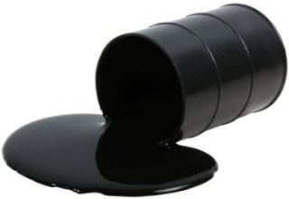

www.NYChicagoRR.org

DATE: February 5, 2016

TO: Members of Congress, 114th Session

RE: Transportation – Please support adoption of proposal
President will propose a $10-per-barrel Charge on Oil to Fund
Clean Transportation Projects

PAGES: One (1) including cover

FROM: Charles Paidock cpaidock@hotmail.com
3211 S. Union Ave (312) 842-5036
Chicago, IL 60616 (312) 714-7790 cell

Link to Article: http://www.msn.com/en-us/money/markets/obama-to-propose-oil-fee-of-dollar10-per-barrel/ar-BBp8Epn?ocid=spartandhp

President Barack Obama will propose a $10-per-barrel charge on oil to fund clean transportation projects as part of his final budget request next week, the White House said Thursday.
The proposal, which follows the passage of a bipartisan transportation bill last year, would have difficulty clearing the Republican-controlled Congress.
Oil companies would pay the fee, which would be gradually introduced over five years. The government would use the proceeds to fund high-speed railways, autonomous cars and other travel systems, aiming to reduce emissions from the U.S. transportation system.
"By placing a fee on oil, the president's plan creates a clear incentive for private sector innovation to reduce our reliance on oil and at the same time invests in clean energy technologies that will power our future," the White House said in a statement.
Obama has prioritized reducing carbon emissions and the use of fossil fuels. But some of his administration's proposals, including the Clean Power Plan, have faced significant opposition at the federal and state level.
Thursday's proposal comes amid a brutal stretch for the U.S. oil industry. Crude prices have fallen nearly 50 percent in the last year to just below $32 per barrel, pressuring profits in the sector.
Shares of major U.S. oil producers were higher Thursday afternoon despite the White House's announcement. Exxon Mobil's stock was up more than 1 percent, while Chevron shares were modestly higher.

